UNIVERSITY OF MINDANAO DIGOS COLLEGE
BACHELOR OF SCIENCE IN INFORMATION TECHNOLOGY


Web-based Election System for the Holy Cross Academy of Digos Alumni Association Inc.

In Fulfillment of the Final Project for IT12/L
(Systems Integration & Architecture)
Submitted by:
EMERSON C. AGAN
NASH ARIAN CARAJAY
CHRISTIAN EMMANUEL B. JACQUIAS

December 2024

Table of Contents

Table of Contents …………….……………………………………………….… ii
Chapter 1 - Introduction………………………………………………………... 1
1.1 Background of the Study 1
1.2 Statement of Objectives 2
1.2.1 General Objectives 2
1.2.2 Specific Objectives 2
1.3 Significance of the Study 3
1.4 Scope and Limitation of the Study 4
1.4.1 Scope 4
1.4.2 Limitation 4
Chapter 2 - Methodology of the Study…………………………………….…… 6
2.1 System Development Life Cycle 6
2.2 System Architecture 6
2.3 Gantt Chart
Chapter 3 - Data Gathering Procedures and Output ……………………….... 9
3.1 Research Design 9
3.2 Data Collection Methods 9
3.3 Data Collection Details 10
3.3.1 Documents 10
3.3.2 Interviews 12
3.3.3 Observations 16

Chapter 4 - The Existing System ……….……………………………….……. 17
4.1 Company Background 17
4.2 Description of the System 19
4.3 Data Flow Diagram 20
4.4 Data Dictionary 20
4.5 Problem Areas 23

Chapter 5 - The Proposed System ……………………………………………. 24
5.1 System Overview 24
5.2 Process Specification 24
5.2.1 Data Flow Diagram 24
5.2.2 Data Dictionary 25
5.3 Data Specifications 35
5.3.1 Entity Relationship Diagram 35
5.3.2 Tables / Files Layout 36
5.4 Screen Layout / Form Specifications 36
5.5 Report / Form Specifications 39
5.6 Program / Module Specifications 40

Chapter 6 - System Coding (Prototype) …………………………………....... 41
6.1 Programming Language 41
6.1.1 Frontend 41
6.1.2 Backend 41
6.2 Special Purpose Language Tools 42
6.2.1 Development Tools 42
6.2.2 Frameworks and Libraries 42
6.2.3 Database Management 42
6.2.4 Hosting and Deployment 43

Chapter 7 - System Testing Plan ……………………………………………... 44
7.1 Testing Stages 44
7.1.1 Preliminary Testing 44
7.1.2 Alpha Testing 44
7.1.3 Beta Testing 45
7.2 Testing Schedules 45

Chapter 8 - System Implementation Plan …………………………………… 46
8.1 Resource Requirements 46
8.1.1 Hardware Requirements 46
8.1.2 Software Requirements 46
8.1.3 Human Resource Requirements 46
8.2 Implementation Plan 47
8.1.2 Site Preparation 47
8.2.2 Personnel Training 47
8.2.3 System Conversion 48
8.2.4 Data Conversion 48
8.2.5 Implementation Schedule 48

Chapter 9 - System Maintenance Plan ……………………………………….. 49
Bibliography 50

CHAPTER 1

INTRODUCTION

1.1 Background of the Study
For many years, the Holy Cross Academy Alumni Association has served as a community where former students stay connected, support school activities, and take part in collective decision-making through elections. As the alumni population grew, so did the need to elect officers who could faithfully represent the organization and lead its programs. Despite this, the association still relies on traditional, fully manual processes—from collecting nominations on paper to counting ballots by hand. While these methods have long been part of the institution’s practices, the growing number of alumni has made the limitations of manual workflows impossible to ignore.

In the current setup, the nomination and voting processes involve paper forms, physical submissions, and face-to-face tallying. These introduce challenges that many organizations with manual elections also face: slow processing, difficulties verifying voter eligibility, duplicated or invalid ballots, miscounts, and inconsistent record-keeping. Alumni residing far from Digos City—especially those abroad—often struggle to participate at all, resulting in lower engagement and reduced representation. As elections play a crucial role in maintaining organizational transparency and democratic involvement, these barriers weaken the overall integrity of the process.

These issues are not unique to HCAD. Researchers studying traditional elections note that manual systems frequently suffer from inefficiencies and vulnerabilities, making them prone to human error and disputes (Bayo, 2020). Many academic institutions and organizations that have shifted to online election systems report substantial improvements in transparency, participation, and speed of result consolidation (Adegboye & Bello, 2021). For example, universities that adopted web-based voting platforms experienced smoother authentication processes, more accurate tallying, and fewer conflicts around election results (Singaravelu & Kumar, 2019). These findings reflect a broader trend: as communities become more digitally connected, manual voting systems no longer meet the expectations for fairness, accessibility, and secure record-keeping.

Given these realities, there is now a strong need for the Holy Cross Academy Alumni Association to modernize its election process. A web-based nomination and voting system can help eliminate many of the long-standing issues of manual elections by centralizing voter records, securing ballot submissions, reducing administrative workload, and giving alumni—regardless of where they live—an easier, more transparent way to participate. By embracing a digital approach, the Alumni Association can build a more inclusive, trustworthy, and future-ready.

1.2 Statement of Objectives
Elections play a central role in the Holy Cross Academy Alumni Association, serving not only as a way to choose leaders but also as a way to strengthen the sense of community among its members. However, the current manual workflows make it difficult to run a fair, fast, and inclusive election. To address these long-standing issues, this study aims to develop a system that modernizes the entire nomination and voting process.

1.2.1 General Objectives
To develop a web-based Nomination and Voting System designed to simplify, secure, and centralize the entire election process of the Holy Cross Academy Alumni Association inc. (Digos City Chapter).
1.2.2 Specific Objectives
- To create a centralized voter database that securely stores and manages alumni records, ensuring accurate verification prior to election participation.
- To design a nomination module that enables eligible alumni to submit nominations digitally while enforcing election rules such as “one nomination per voter per position.”
- To automate the voting process by providing a secure digital ballot where authorized voters can cast, confirm, and submit their votes conveniently through their devices.
- To integrate a real-time vote-counting mechanism that automatically tallies votes and helps administrators avoid errors common in manual counting.
- To provide an administrative dashboard where election committees can monitor nominations, validate voter accounts, track voting progress, and manage system settings.
- To enhance transparency and fairness by implementing audit logs, session controls, and built-in validation rules that prevent duplicate or invalid submissions.

1.3 Significance of the Study
The development of a online nomination and voting system carries meaningful benefits not only for the Alumni Association but also for the broader community of graduates who wish to stay connected. For the Alumni Members, the system offers a convenient and accessible way to participate regardless of their location. Alumni who now live outside Digos City—or even overseas—will no longer struggle with physical submission or travel just to cast their vote. This encourages higher participation and ensures more diverse representation.
For the Election Committee and Administrators, the system reduces the heavy workload associated with validating voter eligibility, managing nominations, and tallying votes. Automating these processes minimizes human error and speeds up the release of results, contributing to a fairer, more convenient and more transparent election.

For the Organization as a whole, the system strengthens trust in the election process. Since every action from account verification to vote submission is digitally tracked and logged, disputes are significantly reduced. A more efficient and accountable election system ultimately supports the Association’s goal of selecting capable leaders and fostering a sense of unity and shared responsibility. By embracing digital transformation, the Holy Cross Academy Alumni Association takes an important step toward more secure, accessible, and future-ready-governance.

1.4 Scope and Limitation of the Study

1.4.1 Scope
This study focuses on developing a web-based system that supports the full election cycle of the Holy Cross Academy Alumni Association—specifically for the 2025–2027 term. The system covers essential election functionalities, including:
- Voter Registration & Manual Verification
The system gathers voter information, but administrators are still responsible for verifying alumni identity before granting account access.
- Nomination Management
Alumni can nominate candidates for official positions online. The system enforces nomination rules to maintain fairness.
- Secure Digital Voting
Eligible voters gain access to a digital ballot that supports one vote per position and prevents duplicate voting.
- Real-Time Vote Tabulation
Votes are automatically counted and reflected in the admin panel.
- Administrative Tools
COMELEC members and the Election Chairman can oversee voter accounts, validate nominees, monitor progress, and publish results.
- Browser-Based Platform
The system is accessible via desktop or mobile browsers and does not require a mobile app installation.

1.4.2 Limitation
The system has the following limitations:
- No Existing Digital Roster - The system starts with a fresh database, as historical alumni information cannot be imported due to the lack of a validated digital list.
- Limited Authentication Methods - Identity verification relies solely on manual checking by administrators. The system does not integrate advanced identity verification or third-party authentication services.

- Core Election Features Only - The scope is restricted to registration, nomination, voting, and vote counting. It excludes features such as alumni engagement tools, financial modules, or communication platforms
- Web-Only Implementation - The system operates exclusively as a web application and does not include native Android or iOS apps.
- No Automated Communication Channels - SMS or email notifications for reminders are not included and will be handled manually.

CHAPTER 2

METHODOLOGY OF THE STUDY

2.1 System Development Life Cycle
The Agile methodology will be used for this project, specifically utilizing the Scrum framework. Using Scrum allowed the team to break the project into small, manageable iterations called sprints, each producing working components of the system. This approach not only ensured consistent progress but also made it easier to gather feedback, conduct revisions, and refine system features as development advanced.
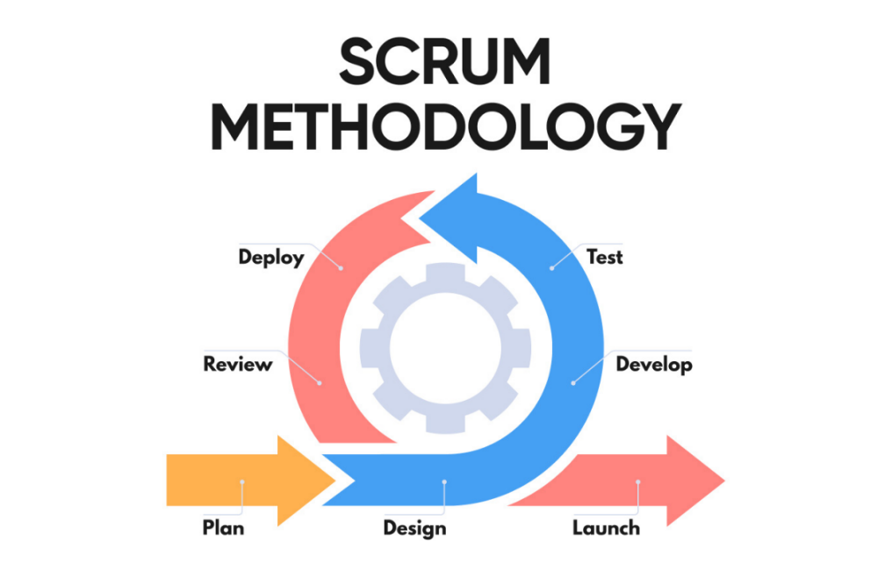
Figure 1: System Development Life Cycle of the Web-Based System

Backlog Creation
The development process began with the creation of a product backlog, which served as the master list of features and functionalities needed in the system. These items were identified based on user interviews, document reviews, and observations of the previous manual workflow used by the Alumni Association.
During this stage, the team prioritized tasks according to their importance in ensuring a smooth, secure, and error-free election process.
 | Features Backlog
1 | Development of the voter registration and alumni verification module
2 | Implementation of the nominee submission and eligibility validation module
3 | Creation of the secure online voting module with encrypted vote casting
4 | Development of automated vote counting and real-time result tabulation
5 | Implementation of admin and user access control for monitoring and system management
Table 1: Product Backlog of the prioritized list of features for the system

Sprint Planning
The team will collaboratively plan and conduct sprints, selecting high-priority items from the backlog to be developed in each sprint cycle.

Below is a breakdown of the sprint structure used throughout the system development:

 | Sprints
Sprint | Description
1 | Development of the Core User Interface
 |  | Create responsive UI layouts for
 |  | Login Page (Quick entry)
Dashboard
AdminPanel
Voter Registration Page (Quick entry)
 |  | Nomination page
2 | Development of the Voter Registration & Verification Module
 |  | Create database structure & ERD for alumni voter records
 |  | Define fields: Full Name, Batch, Contact No., Email, Alumni ID, Verification Documents
 |  | Implement CRUD operations for voter records
 |  | Create UI for voter registration & editing
3 | Development of the Nominee Management Module
 |  | Create database tables for nominees (Nominee Info, Category, Status)
 |  | Design UI for nomination submission (self-nomination or peer nomination)
 |  | Add file upload for credentials/background documents
4 | Secure Voting & Real-Time Vote Counting Module
 |  | Implement secure vote-casting mechanism
 |  | Ensure “one voter, one vote” validation
 |  | Encrypt stored votes for security
 |  | Create UI for the voting interface (candidate list, vote buttons)
 |  | Implement CRUD (Create, Read, Update, Delete) operations
5 | Admin Panel, Monitoring & Audit Logs
Build admin dashboard for monitoring:
Total voters
Verified accounts
Approved nominees
Voting progress
Implement audit trail system (log-in actions, votes, approvals)
Add role-based access:
Super Admin
Staff Admin
Add system analytics and summary reports
6 | System Integration, Testing, and Deployment
 |  | Integrate all modules (registration → nomination → voting → results)
 |  | Conduct system testing (unit test, security test, usability test))
 |  | Fix bugs and refine user experience
 |  | Implement backup & restore function for database
 |  | Deploy system to live server
Table 2: Sprint Backlog of the more specific tasks from the Product Backlog

Sprint Reviews and Retrospectives
At the end of each sprint, the team will review the completed work and gather feedback to improve the next iterations. Retrospectives will focus on refining team processes and addressing challenges encountered during development.

Testing and Quality Assurance
Comprehensive testing will be conducted throughout and after sprint cycles. This phase will involve unit testing and integration testing to ensure system reliability and usability.

Deployment and Training
The system will be deployed in a live environment. Training sessions will be conducted to familiarize users, such as the HCAD Staff ,Admin and Focal Persons.

Maintenance and Enhancement
After deployment, constant maintenance and iterative improvements will be employed based on the feedback from users who will guide future updates, ensuring that the system will remain relevant and effective.
The Scrum-Agile framework emphasizes adaptability and incremental delivery, enabling the team to respond promptly to the feedback from the UMDC CEC staff and evolving requirements

2.2 System Architecture
The system follows a Three-Tier Architecture, ensuring separation of concerns, scalability, and security.
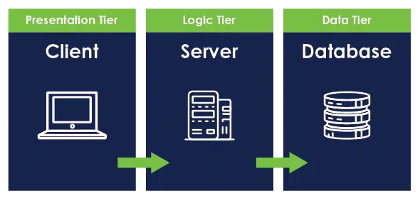
Figure 2: System Architecture for the HCAD

Presentation Layer
- Vue 3 + Vite SPA
- Tailwind CSS
- Interfaces for login, nomination, voting, admin tools & dashboard
Application Layer
- Django REST Framework
- Handles authentication, session control, nomination logic, vote validation, tallying, and administrative operations
Data Layer
- SQLite (development), MySQL/PostgreSQL (production-ready)
- Stores voter profiles, nominations, candidates, votes, audit logs, notifications

2.3 Gantt Chart
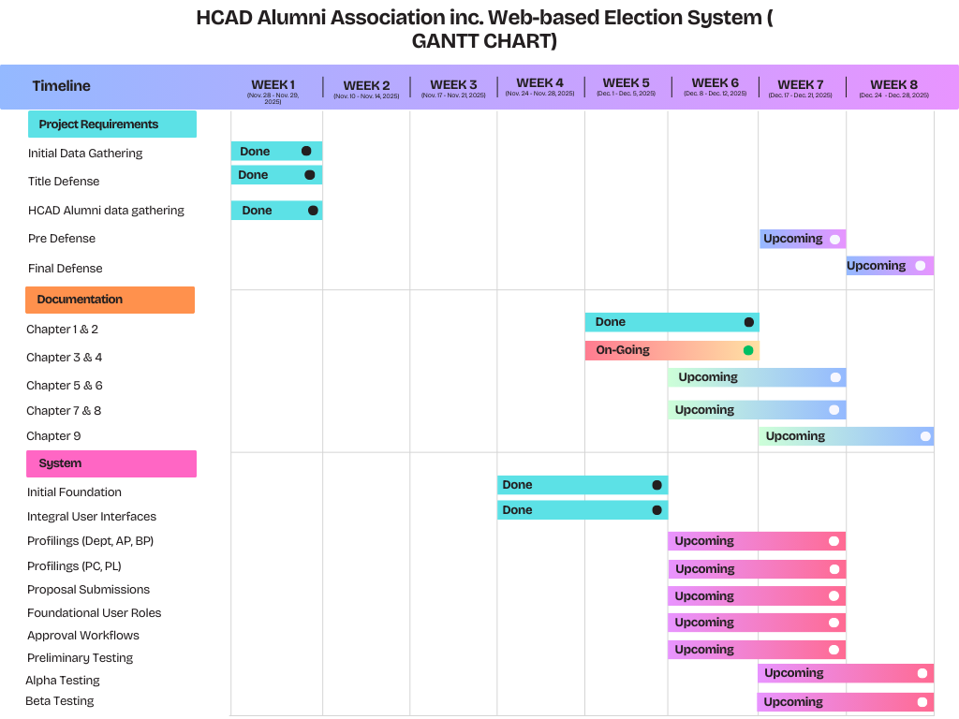
Figure 3: Gantt Chart of the tasks made for the HCAD Alumni Association Inc.

CHAPTER 3

DATA GATHERING PROCEDURES AND OUTPUT

3.1 Research Design
This study will utilize a qualitative descriptive research design. This is appropriate in studying the present nomination and voting procedure at the HCAD Alumni Association Inc. (Digos City Chapter), enumerating challenges faced by the present administration, and determining what the necessary requirements are for a more secure, efficient, and transparent
Digital voting system
The qualitative approach allows the development team to obtain detailed descriptions of workflows, tailored to meet the particular needs of the organization, such as:

Voter Registration & Verification: A prerequisite registration module for 50,000 estimated active members where no current digital roster exists; then, a manual verification by the administrators, which would allow access to the ballot.

Nomination Procedures: Handling nominee submissions for major positions of the Society, such as the President, Vice President, etc., where nominees are automatically included by nomination without further confirmation.
Election Administration: Implement identified voting, non-anonymous to admins, to ensure one vote per person. It provides a real-time dashboard to monitor results.
This enables the creation of system features that precisely meet real institutional needs.
3.2 Data Collection Methods
The following data collection methods were used to obtain insights and requirements for developing the HCAD Alumni Nomination and Voting System.
:

1. Document Analysis
a. Existing election-related forms such as:
- manual nomination forms
- voter lists and alumni directories
printed election guidelines and procedures
b. Templates and spreadsheets previously used by the Alumni Officers for managing:
- nominee information
- vote counts
- election result summaries
c. Records from past alumni elections, including:
- previous ballots (if available)
- election reports

2. Interviews
a. Key personnel were interviewed to understand issues encountered in:
- managing alumni profiles
- validating voter eligibility
- conducting nominations
- tallying votes and reporting results
b. Respondents included:
i. Alumni Association President
ii. Election Committee Members

iii. Staff responsible for preparing nomination and voting materials
3. Observations
a. Actual workflows for:
- voter verification
- nominee submission and approval
- manual vote counting and tallying
b. Handling and filing of election documents
c. Current challenges experienced during:
- manual processing
- organizing voter lists
- ensuring fairness and transparency in results

3.3 Data Collection Details

3.3.1 Documents
During the data gathering phase, the researchers attempted to obtain documents related to the previous election cycle, such as nomination forms, voter lists, tally sheets, and official election reports. However, these documents were not available because the current project sponsor and participating officers were not part of the administration during the last election. As a result, they had no direct access to the materials, records, or files used in the previous manual processes.

This lack of documentation itself highlights one of the major issues within the Alumni Association’s election workflow: the absence of a centralized and well-preserved record-keeping system. Without organized files or digital archives, transitioning responsibilities between officers becomes difficult, and institutional election knowledge is easily lost from one cycle to the next.

Because of this limitation, the researchers relied on interviews, recalled procedures, and personal accounts from current officers to understand how the previous system functioned. These insights provided enough detail to identify operational gaps and define the necessary requirements for a modernized, web-based nomination and voting platform.

The unavailability of previous documents further emphasizes the need for the proposed system—one that secures, stores, and centralizes election data so that future officer transitions no longer risk losing critical information.

3.3.2 Interviews
Interview Format
A semi-structured interview approach was adopted to give the respondent ample opportunity for free expression of experiences while keeping the discussion focused on key areas. Each interview session had questions addressing:
- Current nomination and voting workflows
- challenges encountered with the manual verification and vote tallying
- issues of fairness, precision, and transparency
- expectations, preferences, and recommendations regarding the new automated system.
.

Interview Participants
Name | Position | Date of Interview
Giovanni Kish Basilgo | HCAD President | November 29, 2025
Table 3: Participant interviewed

Interview Manuscript
Below are the important excerpts or key points taken from the interviews conducted with Dr. Giovanni Kish Basilgo (HCAD President):
Respondent: It should only include the positions that are electable.
And if you import them or share them to the GC if you import the members the positions also need to be nominated.
Respondent: And once they are able to log in, they can already nominate and they can already vote.”
Once the nominations are closed, the nominees for each particular position will drop down and those will become the official choices in the system that users can vote for.
Respondent: At the end of the voting, on election day, after everything is done, the system will summarize the results President, Vice President, and so on.
Respondent: Before a user or an alumnus can create an account, vote, or nominate, they must first create an account and request access from the admin. The admin will grant the access.
Respondent: And once they are able to log in, they can already nominate and they can already vote.”
Interviewer: Yes, sir.

Interview Summary
The interview provided crucial insights into how elections were previously handled, even though no documents from the past election could be provided. The HCAD President recalled the general flow of the manual process based on his experience as a member and observer, not as an officer during the previous cycle. He described how nominations were manually collected, verified by administrators, and then consolidated into a list of eligible candidates.
These interviews became the primary source of truth for reconstructing the old workflow and helped shape the requirements for a more secure, structured, and transparent online system.
Population and Process Profile
The institution functions based on a controlled population with 201 students and 11 administrative staff members. Although this is considerably smaller in scale compared to the 50,000-member alumni association, the core process issues are exactly the same:
Manual and ineffective processes: Students' nominations and their respective voting are being done manually, hence the Alumni Association finding that non-automated processes are time-consuming and prone to errors.

3.3.3 Observations
Direct observation was limited because no prior election documents or stored records were available for review. Instead, the researchers observed current administrative routines, general alumni coordination processes, and how election-related tasks are handled informally among officers today.

The following issues were noted:
- Fragmented information flow:
Because past records were not preserved, officers struggle to reconstruct previous election workflows. This leads to inconsistencies every election cycle.
- Verification challenges:
Without a unified alumni database, verifying whether an alumnus is in “good standing” depends on memory, ad-hoc lists, or word-of-mouth.
- Communication delays:
Election announcements are spread across multiple platforms, such as group chats and social media, resulting in inconsistent reach.
- Manual counting risks:
All vote-tallying is done manually, increasing the chances of miscounts and disputes, especially with a growing alumni population.
- No historical reference:
Since no documents were kept from previous elections, the incoming officers have no guide to ensure continuity, fairness, or proper procedures. This is one of the strongest arguments supporting the shift to a web-based system.

CHAPTER 4

THE EXISTING SYSTEM

4.1 Company Background
The Holy Cross Academy of Digos Alumni Association Inc. (Digos City Chapter) is composed of former students who continue to support the institution through various community-building activities, events, and organizational initiatives. As part of its democratic governance, the Association holds elections every term to select officers who will lead the organization, coordinate programs, and represent the alumni body.

With thousands of active alumni distributed across different regions and countries, the Association plays a vital role in maintaining community engagement and ensuring that alumni voices are heard. However, despite its large and growing membership, the processes involved in managing elections remain entirely manual, and institutional election records are not consistently preserved across terms.

This situation creates management challenges for incoming officers, especially during transitions where no formal documentation or archival system has been maintained.

4.2 Description of the Existing Election System
The current election process of the HCAD Alumni Association is fully manual, relying heavily on paper-based workflows, verbal coordination, and the individual efforts of officers who happen to be active during a given election cycle. Because the current officers were not part of the previous administration, they were unable to retrieve any election-related documents such as:

- Past nomination forms
- Voter eligibility lists
- Tally sheets
- Candidate records
- Official reports or declarations

As a result, there is no standardized reference for how previous elections were carried out. Instead, the existing system has been reconstructed solely through interviews and recollections of those familiar with past practices.

Based on these accounts, the existing manual system typically involves:

- Manual Nomination Collection
Alumni nominate candidates by submitting handwritten or typed forms. These are collected physically or informally through various communication channels.
- Eligibility Checking by Administrators
Officers manually cross-check nominee and voter details against incomplete or outdated membership lists, often relying on personal familiarity rather than formal records.
- Paper-Based Voting Process
Voters cast ballots by filling out physical forms during alumni gatherings. Participation is limited, especially among alumni living outside the locality.
- Manual Vote Counting
Votes are tallied by hand. This process is slow and prone to errors, especially with larger numbers of ballots.
- Result Consolidation
Results are summarized manually and announced verbally or through group chats.

This manual process lacks structure, consistency, and transparency, making it difficult to ensure fairness or accuracy across election cycles.

4.3 Data Flow Diagram of the Existing System

Because the existing system is fully manual and undocumented, the Data Flow Diagram (DFD) shown here is a reconstructed interpretation based on interviews and observed practices. It illustrates how information currently flows between alumni, officers, and physical records during elections.
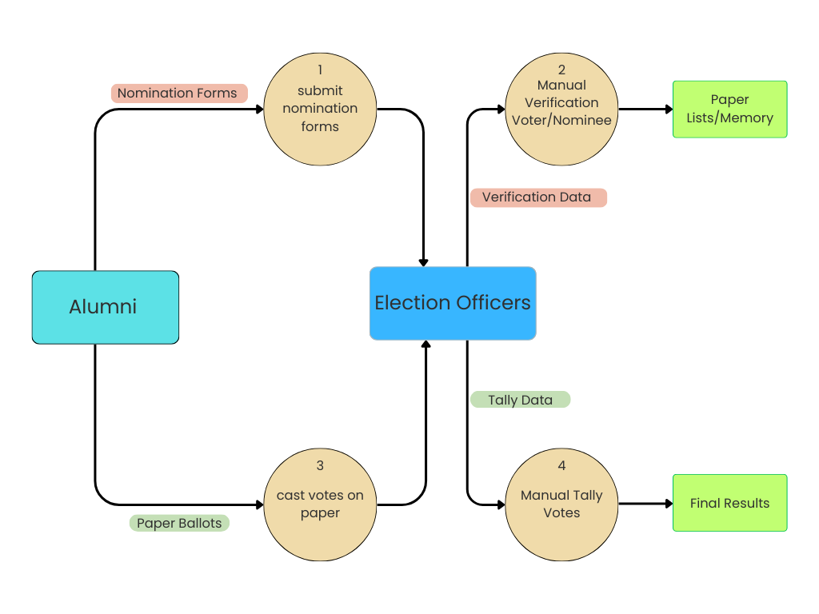
Figure 4: Data Flow Diagram of the Manual Election System.

4.4 Data Dictionary
Since no official documents from past elections were available, the following data dictionary is a modeled representation of what the manual system likely handled based on interview insights:
Voter Information
Field | Description | Notes
Full Name | Name of the alumnus | Manually written by voter
Batch Year | Batch Year | Used inconsistently
Contact Details | Phone or email (optional) | Not standardized
Eligibility Status | Whether the voter is recognized by officers | Often based on personal familiarity
Nomination Details
Nominee Name | Person being nominated | Submitted manually
Position | Role being nominated for | Not always formalized
Submitted By | Person who nominated | No verification mechanism
Vote Records
Candidate Voted | Selected candidate per position | Written on paper ballot
Voter Identity | Who submitted the vote | Not always tracked
Ballot count | Manual tally | Prone to error
Table 3: Data Dictionary of the Existing Manual Election System

These table reflect the limitation of the manual issues were identified in the existing system.

4.5 Problem Areas
Through interviews and observations, several major issues were identified in the existing system:
- Lack of Documentation
Past election forms, records, and tally sheets were not preserved, making it difficult to review or confirm historical election data.
- Verification inconsistencies
Without a centralized alumni database, verifying voter eligibility depends heavily on the officers’ personal knowledge.

- Low Participation
Alumni living outside Digos City or abroad have no accessible means to participate in the manual voting process.
- High Risk of Error
Handwritten ballots, manual tallying, and unstructured forms significantly increase the chance of miscounts of disputes.
- No Tran sparency Protocols
There is no formal logging system, audit trail, or standardized reporting process.
- No Continuity Across Terms
Since documents are not archived, election procedures change depending on who is in charge, leading to confusion and inefficiency.
Chapter 5
The Proposed System

5.1 System Overview
The proposed Web-Based Nomination and Election System is a fully deployed platform designed for the Holy Cross Academy Alumni Association (Digos City Chapter). Now hosted at https://hcadalumni.org, the system centralizes all election activities including voter access, nominations, candidate promotion, voting, tallying, and results publication.

A key goal of the system is to eliminate the inconsistencies, data loss, and verification issues present in the former manual process. The system introduces a multi-layer access structure:
- Voter Layer – Alumni enter through a shared passcode and authenticate using Quick Entry (Full Name + Batch Year + Consent).
- Admin / COMELEC Layer – Election administrators access a dedicated frontend console through /admin-login.
- Super Admin Layer – The system owner accesses full backend controls through Django’s native admin interface at /admin.
This layered access ensures security, accountability, and scalability, making the system suitable for long-term use by future election committees.

5.2 Process Specification
The proposed system’s process flow is divided into three major user groups: Voter, Admin / COMELEC, and Super Admin. Each interacts with the system through different interfaces and permissions but all actions flow into a shared backend and database.

5.2.1 Context Diagram (Entire System)
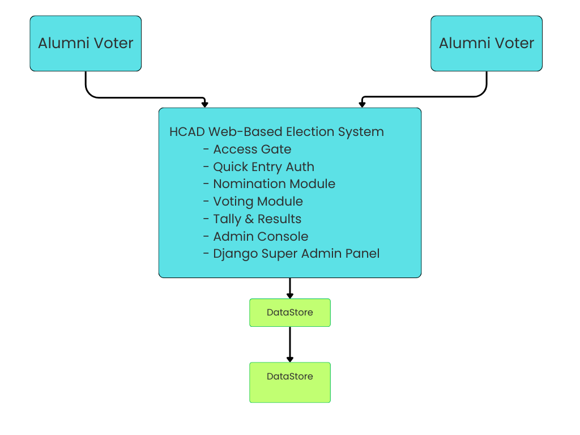
Figure 5: Context Diagram of the Proposed HCAD Alumni Web-Based Nomination and Election System

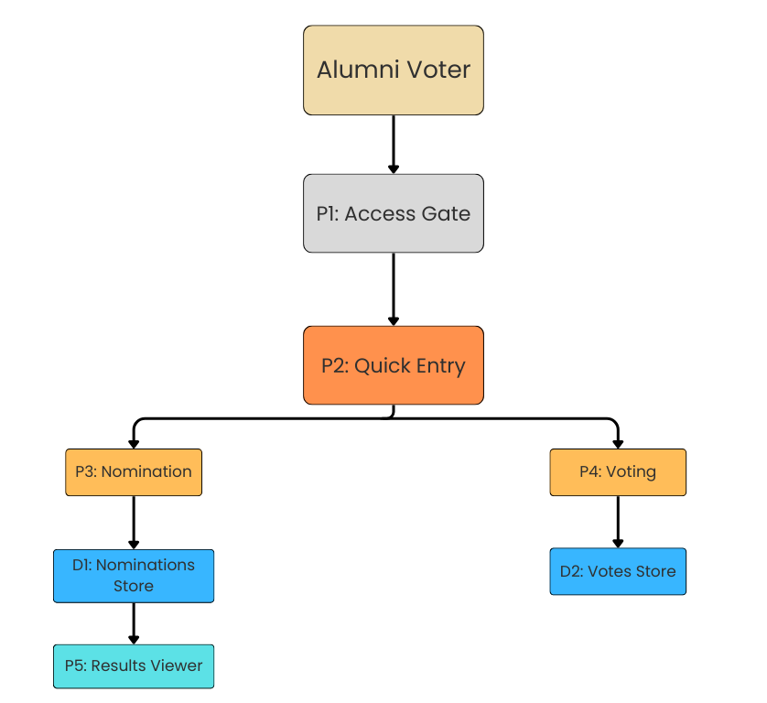
Figure 6: Data Flow Diagram (DFD) for Voter Processes

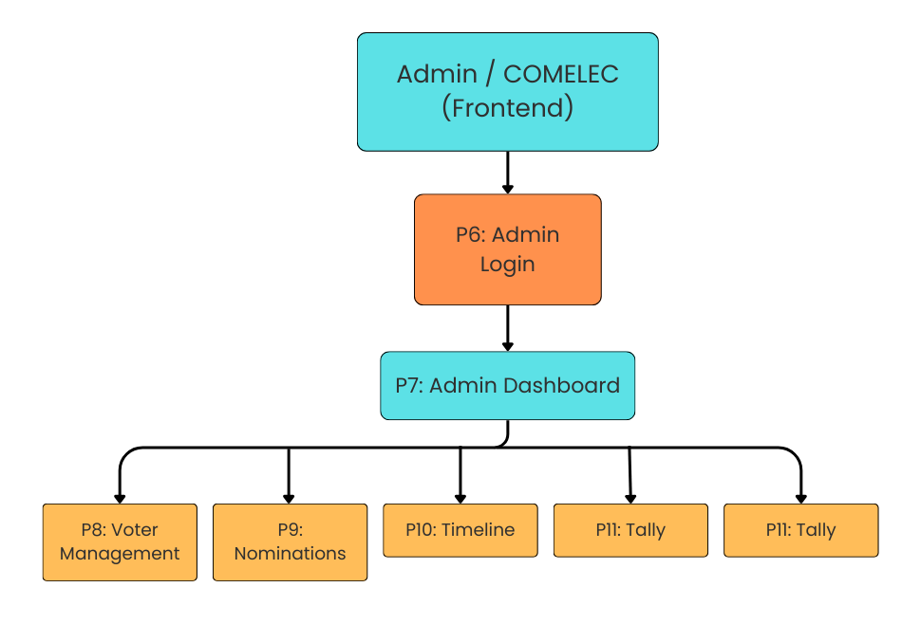
Figure 7: Data Flow Diagram (DFD) for Admin Processes

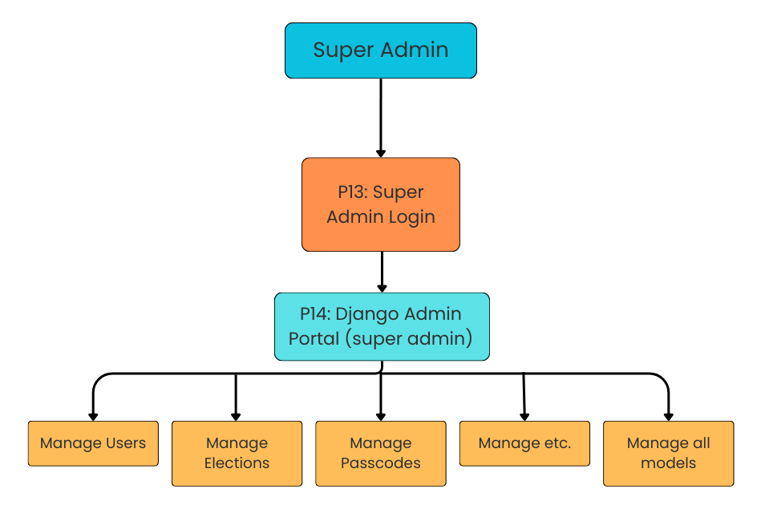
Figure 7: Data Flow Diagram (DFD) for Super Admin Processes

BIBLIOGRAPHY
- B. Bayo, “Design and implementation of an online voting system for institutional elections,” International Journal of Computer Applications, vol. 176, no. 19, pp. 1–7, 2020.
- A. Adegboye and T. Bello, “A secure web-based e-voting system using authentication and verification techniques,” Journal of Information Engineering and Applications, vol. 11, no. 4, pp. 45–56, 2021.
- R. Singaravelu and N. Kumar, “University-level adoption of online voting systems: challenges and outcomes,” International Journal of Advanced Computer Science, vol. 8, no. 2, pp. 150–158, 2019.
- V. Podoba, "Agile software development life cycle phases for SaaS founders," SoftFormance, May 25, 2022. [Online]. Available: https://www.softformance.com/blog/agile-software-development/. [Accessed: Dec. 8, 2025].
- S. Vlasic, "Three-tier architecture approach for custom applications," Zirous, Nov. 15, 2022. [Online]. Available: https://zirous.com/2022/11/15/three-tier-architecture- approach-for-custom-applications-2/. [Accessed: Dec. 8, 2025].

